|  |  |
| --- | --- |
|  | **[Design & Analysis of Algorithm]**  **[BSCS – 5 A]**  **Department of Computer Science**  **Bahria University, Lahore Campus** |

**Assignment: 2** Date: Week [5]

Name: _____________________ Roll No: ___________________

|  |  |  |  |
| --- | --- | --- | --- |
| **Evaluation of CLO** | **Question Number** | **Marks** | **Obtained Marks** |
| **CLO statement**   * **CLO 2:** **Analyze the time and space complexity of different algorithms.** | 1 | 2.5 |  |
| **Total Marks** | | **2.5** |  |

**Q1. Identify the worst case time complexity of the following recurrence function using substitution method.**

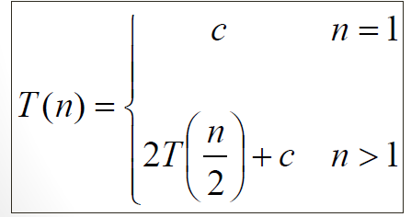

**Q2. Identify the worst case time complexity of the following recurrence function using substitution method.**

